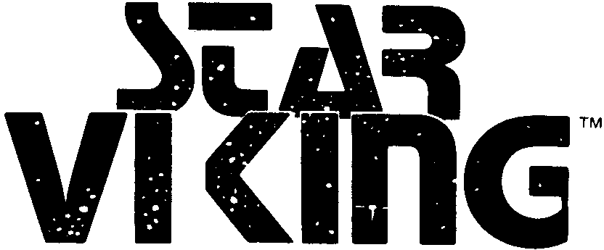

GAME RULES

Two thousand years in the future, in the Outrim Quadrant of the Orion Arm, lie the furthest provinces of the Federation. Beyond these last outposts of an old and decaying civilization there is a vast void of unexplored stars. From this void, in the twilight of the Rule of Man, come the Star Vikings.

Centuries earlier the lost colony ships plunged past the Outrim into the Beyond. They only found poor worlds, with few resources. But civilization began, low in population, high in technology, constantly struggling to survive and grow. Now these rugged survivors are returning to the Federation: to plunder what they need.

A Viking Cruiser drops from hyperspace in an Outrim System. Fighters launch to engage the intercepting patrol boats. Soon the patrol boats are vaporized, and with fighters circling the Cruiser descends into the atmosphere. Grav-tanks and power-armor troopers spill from cargo holds, annihilating the uncoordinated and weak local forces. Raiding parties scoop up civilians for the slave pens. Factories and mines are plundered, libraries emptied, gold and platinum removed from the mints, even art galleries are pillaged. By daybreak the Vikings are gone, leaving behind smoking cities, radioactive craters, and a planet struggling to restore itself.

Against this horror stands the Federation Squadron of the Outrim, with a handful of small warships. The admiral patrols his systems, trying to outfox and outguess the raiders. Aiding him are local defenses, from savage stone-age tribesmen to sophisticated fighters and patrol boats. The stage is set for strategies of double-think and triple-think, epic clashes, and the rise or fall of civilization at the hands of the Star Vikings.

Introduction to Play
Star Viking is a two-player game: one is the Viking player, the other is the Federate player. At the start of the game the Viking player selects his raiding ship(s) and forces, while the Federate player lays out the map tiles and deploys his forces.

The game is played in turns, starting with “Strategic” inter-stellar hyperspace jumps as starships move from system to system. Then if opposing forces end up in the same star system, “Tactical Action” segments are used to resolve the “battle”, one segment for each star system (tile) where opposing forces face each other. Finally, when all the Tactical Action segments are finished, players determine the current political situation, repair damage and build new forces, and accumulate victory points by “buying” them with taxes or plunder.

GAME EQUIPMENT

Star Viking includes, within the box, a rules booklet, two dice, a folded sheet of 154 die-cut cardboard counters (each ½” square), and a sheet of 12 map tiles, each representing a star system. The counters and map tiles are punched out for use in play. Small zip-loc storage bags, available at most supermarkets, are ideal for holding the counters and tiles between games.

Rules Booklet
The best way to learn Star Viking is to quickly read this rules booklet once through. Then immediately try a game, even if it is solitaire. Refer back to the rules during your first game, re-reading the fine points as necessary. After the first game or two you will know and understand the rules clearly.

Star System Map Tiles
The game includes twelve different star system map tiles. Each represents a star system and important items orbiting that star, including planets, moons, asteroids, and starcities (artificial city structures orbiting in outer space). The star system is divided into orbits, and each orbit has a number of different sectors. Larger planets are composed of two or more sectors, while moons, asteroids, and starcities are each a single sector. Each sector is outlined in white solid lines.

In the game, a “sector” is equivalent to a “square” or “hex” in other games. The die-cut unit counters are deployed in sectors, and when opposing units are in the same sector battles occur. There are three main types of sectors: deep space (in black with square out-line), atmospheric (in blue-green with irregular outline), and vacuum (all other colors including grey, tan, magenta, orange, red, etc. usually with a circular outline, sometimes an irregular outline). Some sectors are touching, since they compose a planet, while in other cases, each sector is separate within the orbital path.

On the next page is a sample star system tile:

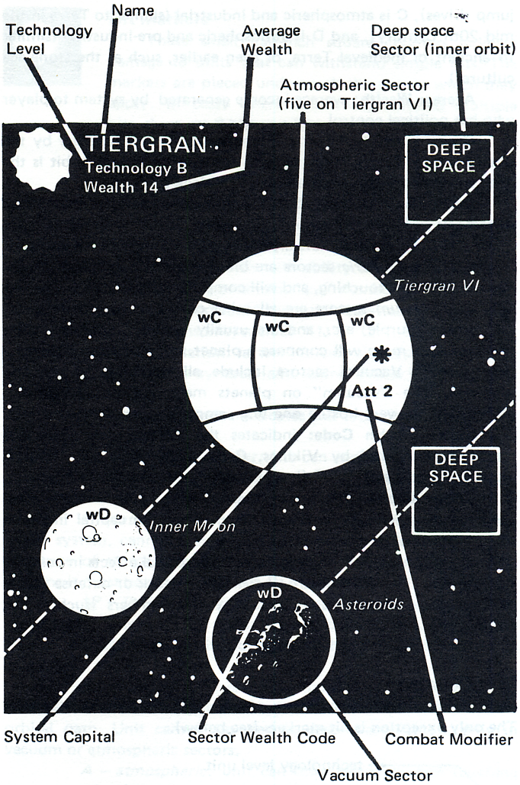
Map Tile Definitions & Explanations
Name: name of the star system given by its residents.

Technology level: local technology, indicates type of local defense allowed. Local defenses must be equal to technology level, or one level less. Technology is rated from A (highest) to D (lowest). A is interstellar technology, B is interplanetary only (no hyperspace jump drives), C is atmospheric and industrial (similar to Terra in the mid 20th Century), and D is atmospheric and pre-industrial (similar to ancient or medieval Terra, or even earlier, such as the stone-age cultures).

Average Wealth: average income generated by system to player who has political control.

Orbit: a group of two or more sectors linked together by the dotted white “Orbit” line. One of the sectors in each orbit is the deep space sector, square shaped with a black background.

Sector: one “playing space” in the game. There are three types of sectors:

Deep space sectors are black with a square white outline.

Atmospheric sectors are blue-green and irregular in shape. Two or more
are touching, and will compose a planet.

Vacuum sectors are all other colors, including grey, red, tan, orange, purple, etc., and are usually circular, although some-times two or more will compose a planet, and therefore be irregularly shaped. Vacuum sectors include all starcities, moons, and asteroids. The “vacuum” on planets means either a very thin atmosphere or a very hostile one (e.g., ammonia, methane, chlorine).

Sector Wealth Code: indicates the relative richness if the sector is plundered by Vikings. Codes vary from wA (level A wealth, the greatest) to wE (level E wealth, the lowest).

System Capital: one sector, marked with a star, is the political center and capital of the system. Control of the capital indicates political control of the system.

Combat Modifier: some sectors have special effects in combat. For example, the EW (electronic warfare), attack or defense values of units may change, as indicated by the numbers (such as +1 -2, etc.).

Unit Counters
The small half-inch square playing pieces are termed “units”. The only exception is hit markers (see Hit Markers below).
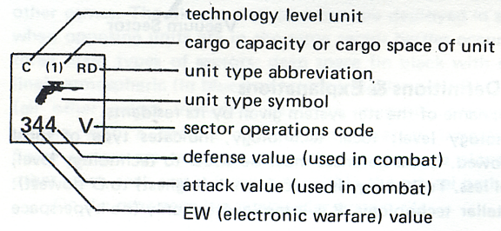

Unit Counter Definitions & Explanations
Technology Level: technology needed to build or repair the unit, from A (highest) to D (lowest).

Cargo Capacity/Space: units with ability to carry cargo are indicated with a “c1”, “c2”, or similar “c—” number. Units that can be carried as cargo are indicated by a parenthesized number indicating the space they consume, such as “(1)”, “(2)”, etc.

Unit Type Abbreviation: letters indicate the type of unit. See the listing of unit type symbols and abbreviations below for the exact types in the game.

Sector Operations Code: indicates the type of movement and placement allowed.
S — starship movement: unit can make hyperspace jumps and can move from sector to sector as desired; can be placed in any type of sector.

P — interplanetary movement: unit can only move within a star system, cannot make hyperspace jumps. It can be placed in any type of sector within the star system. To move between star systems it must be carried as cargo (if possible).

*P — limited interplanetary movement: unit can only move within one orbit of a star system, but can be placed in any type of sector in that orbit. To move further it must be carried as cargo.

V — vacuum: unit can only move between touching sectors, cannot move between unconnected sectors even if in the same orbital path. Unit cannot be used in deep space sectors, only in vacuum or atmospheric sectors.
A —atmospheric: unit can only move between touching sectors, and can only be in atmospheric (blue-green color) sectors.

Defense Value: number indicates the strength of the unit’s defenses in combat, the higher the better.

Attack Value: number indicates the strength of the unit’s attacking firepower in combat, the higher the better.

EW Value: number indicates the sophistication of electronic sensors, computers, scanners, decoys, etc., that play an important role in combat. (EW means electronic warfare.)

Unit Type Symbols & Abbreviations

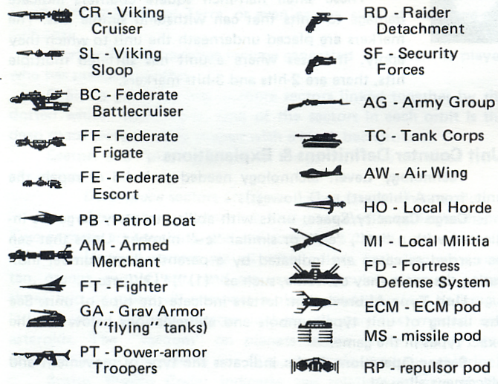

Unit Color Codes
Viking Units use red-colored counters. Viking spacecraft (S, P, *P operations code) have a black background with red numbers and symbols. Viking vacuum and atmospheric troops (V and A operations code) have a red background with black numbers and symbols.

Federate units use blue-colored counters. Federate spacecraft have a black background with blue numbers and symbols. Federate vacuum and atmospheric troops have a blue background with black numbers and symbols.

Local forces units use green-colored counters. Local spacecraft (P and *P operations code) have a black background with green numbers and symbols. Local vacuum and atmospheric troops (V and A operations code) have a green background with black numbers and symbols.

IMPORTANT: Multi-Hit Color: some units can absorb multiple
hits, and are only destroyed by critical hits and/or accumulated nor-mal hits. These units have white-colored values and operations code along the bottom line of the counter. Other units with black-colored bottom line (or normal background color, such as red, blue, or green) are destroyed by a single hit. Units with the white-colored bottom line are termed MULTI-HIT UNITS.

Hit Markers
These small half-inch square counters indicate damage to units that can that can withstand simple hits.


The markers are placed underneath the unit to which they apply. In cases where a unit has suffered multiple hits, there are 2-hits and 3-hits markers.

STARTING SET-UP
Star System Tiles
The Federate player shuffles the twelve star system map tiles. He randomly selects nine or ten (his choice), and announces their names to the Viking player. The remaining two or three are returned to the box, they are not used in the game. The selected tiles represent the “map” of the star systems in the Outrim Quadrant for the game. The Federate player should set up a screen of books or a box to keep them “secret” from the Viking player until Viking units enter that system.

Local Defense Deployment
The Federate player takes all the green local defense units, shuffles them, and selects ten at random. These ten are put aside, for later construction. The rest he can place on any or all of the selected tiles. Local defenses placement should be kept secret until the Viking player actually arrives in the system and starts a Tactical Action segment.

Technology Limitations: local defense units in a system must either match the technology level of the system, or be one level below. For example, a technology B star system can only have B and C level local defense units.

Federate Forces Deployment
The Federate player is allowed three Frigate (FF) and three Escort (EE) units, with a full load of cargo for each. The cargo can be any mixture of blue Federate units, regardless of the cost or values. See Cargo rules for details. These units with cargo are deployed in any star system(s), regardless of technology level. More than one can be placed in the same system.

Quadrant Capital: the Federate player must announce which star system contains the Federation Quadrant Capital. This is represented by the blue Fort Defense unit (FD type, 769 V). The exact sector where this unit is located need not be revealed. This unit must be in a technology A star system if one exists, otherwise it is placed in a technology B system.

Other Federate Units are put aside, and only appear as new construction during the game.

Viking Forces Deployment
The Viking player rolls one die, announces the result, and adds it to 60 for the number of Mega-credits he has to “spend” on his starting forces (will be 61 to 66). Any Mega-credits unspent can be accumulated for future repairs or construction, but cannot buy victory points. The Viking player can only “buy” his own red units, and the choice can be kept secret until the units actually appear in a star system and must be revealed (see Tactical Action segment rules). All Viking units start at the Viking “home base” planet beyond the playing area. Cost of Viking units (to build at the start) are: CR-45, SL-30, FD-10, GA-7, PT-6, PB-6, FT-4, RD-2, Missile Pod-4, ECM Pod-3, Repulsor Pod-2.

TURN PROCEDURE

Each turn represents one to two months of time (period of one hyperspace jump between stars, plus a week or two for battles and cargo handling). The turn is divided into segments to control the game’s flow. Both players will do things each segment.

1. Strategic Segment: (interstellar hyperspace movements) the Federate and Viking players may both move their “S” operations code units (with cargo) to new star systems. In some cases cargo can be loaded or unloaded before and after these moves.

2. Tactical Action Segment(s): (star system battles) in each star system with both Viking and Federate-controlled units, a separate Tactical Action segment is played (one segment per star system). The Viking player determines the order of segments. Each segment is played in Rounds of four Phases. There are as many rounds as needed in each segment, until the action ends. Each round’s phases are:
(a) Invader movement phase
(b) Mutual combat phase
(c) Defender movement phase
(d) Mutual combat phase
Note: if neither player is in a star system that has units of the opposing player, there will be no “battles” and no Tactical Action Segments in the turn. Play will proceed directly from Strategic Segment to Politics & Economics Segment.

3. Politics & Economics Segment: both players follow the steps below to resolve political and economic situations.
(a) Federation politics, both mandatory and optional
(b) Plunder and Taxation
(c) Repairing Damage & New Construction

STRATEGIC MOVEMENT
Procedure
Strategic movement represents interstellar hyperspace jumps. Only units with an “S” operations code (starships) can make these moves, but they can carry others as cargo. To make a Strategic move, the unit is simply moved from one star system tile to another. A unit can jump to any tile, distance or location is irrelevant.

“Hidden” Movement Procedure: to achieve a hidden movement
effect, the Viking player makes his strategic moves by placing the units moved in the proper destination box on his strategic display sheet. Units already on the display, in a “withdraw from” box must move to some other system. Otherwise, movement is optional (the unit could stay in the same place). Then the Federate player makes his strategic moves, physically moving units from one tile to an-other. Federate controlled systems (tiles) will remain hidden from the Viking, while the Viking display should be screened from the Federate player. Finally, Viking units are removed from the display and placed on the proper star system tile. If the tile is Federate controlled, it must be revealed and a Tactical Action segment will be needed. If the Federate player moves to a Viking controlled tile, that is announced and another Tactical Action segment would be needed for that, etc. Units that move to friendly controlled systems where no enemy units exist or appear, or Vikings at home base, will stay on the concealed tile or display for the rest of the turn.

General Movement Rules: a player can move all, some, or none of his “S” operations code units in the Strategic Movement segment. Units that have withdrawn from Tactical Action (on the previous turn) must make a strategic move to a new star system. Units load and/or unload cargo before and/or after strategic movement, pro-vided the loading or unloading occurs in a star system the player controls. Loading and unloading in a system the enemy controls is only allowed during the Tactical Action segment.

Viking Home Base
The Viking player has a “home base” star system outside the playing area. Only Viking units can make strategic moves to and from the home base. No map tile represents the system, just a box on the Viking Strategic Display.
Home Base Characteristics: the Viking home base star system is A technology and wealth of 10. However, it can build, repair, and deploy B and C technology units as well as A technology units.

TACTICAL ACTION

When Tactical Action Segments Occur
After strategic movement, if both Viking and Federate-con-trolled units are in the same star system, a Tactical Action segment occurs. There is a separate segment for each star system that has opposing units. The Viking player decides in what order the segments are played. One segment must be finished before going to another, and all segments must be finished before going to the Politics & Economics segment of the turn. In effect, each segment is a separate “battle”. There is never any strategic movement during a star system segment (partial exception: see Withdrawal, below).

Invader & Defender: the player who initially controls the star system is the “defender” in that segment. His opponent is the “invader.” This role may vary from segment to segment (even within the same turn), depending on control of each system. The role of invader and defender never changes during a segment.

No Tactical Action: if neither player has units in a star system controlled by the other, there is no tactical action, and play proceeds directly to the Politics & Economics segment of the turn.

Initial Deployment for Tactical Action
When a Tactical Action segment starts, the defender takes all his units and deploys them in any sector(s) on the tile. Any number of units can be deployed in a sector, there is no stacking limit. No unit can be withheld from deployment, all units must be placed in some sector of the tile.

Operations Restrictions: V and A operations code units cannot be placed in deep space sectors; A operations code units cannot be placed in vacuum sectors. The only exception is when these units are cargo carried on other types of units.

Redeployment: normally units are redeployed again for each new Tactical Action segment, positions in the old segment are ignored. However, if invader units are in the system (left over from the previous turn), the defender cannot deploy in sectors the invader occupied at the end of the last Tactical Action segment. In addition, once an FD type unit is deployed, it must remain in that same sector until destroyed. It cannot be redeployed.

Limited Intelligence: defender units stacked in vacuum or atmosphere sectors cannot be examined by the invader unless he also has a unit in that sector. Otherwise, only the top unit will be visible. Neither player can examine units carried in cargo by the enemy, unless the cargo is unloaded or is used (if a pod). Invader units, and defenders in deep space sectors are individually visible, the enemy can examine those stacks (except for cargo).

Invader Deployment: the invader, once he sees the defender deployments, can either immediately withdraw, or make his deployment. Both may occur if desired. Invader units that just arrived in the system via strategic movement are deployed just off the tile, ready to move into deep space sector(s) on the first invader movement phase. Invader units that started the turn already in the star system can be deployed in any sector unoccupied by defenders.

Segment Playing Procedure - Rounds & Phases
The Tactical Action segment for a star system is played in rounds each with four phases. Rounds continue until the “Ending a Segment” rules apply. Phases in each round are always played in the following order:

(a) Invader movement phase
(b) Mutual combat phase
(c) Defender movement phase
(d) Mutual combat phase

In the first round, newly arrived invader units will move onto the tile, into deep space sectors. These units could unload cargo after the move in that deep space sector.

At the end of each round, the invader might be able to request surrenders, and/or the Viking might be able to plunder, see Surrender rules, and Politics & Economics, Plunder rules.

Tactical Action Movement
General Rules: a player can move his units in the star system tile during his own movement phase. Only units on that tile may move, strategic movement is prohibited (partial exception: see Withdrawal below). A player can move all, some or none of his units. Units are moved one by one, or in groups, provided a group begins and ends its move in the same sectors. Moving in groups allows the defender to keep the identity of units within a stack secret. Cargo in a unit travels with that unit until unloaded.

Interplanetary Movement: “S” and “P” operations code units can move from any sector to any other sector on the tile. However, if moving to a sector in a new orbit, the first sector entered must be the deep space sector. On a later movement phase the units could move into some other sector in that orbit, or a deep space sector of another orbit.

Orbital Movement: “*P” operations code units can move from any sector to any other in the same orbit. However (due to high fuel consumption) these units cannot move to another orbit unless carried as cargo. “*P” operations code units can move into and out of the deep space sector in their orbit, and are treated as P code units for all other purposes.

Planetary Movement: “V” and “A” operations code units can only move to an adjacent (touching) sector on the same planet. They cannot “jump” to another non-touching sector in that orbit, much less a new orbit, unless carried as cargo. “V” operations code units can be placed in individual vacuum sectors in an orbit, including asteroids and starcities, but will be unable to leave unless carried as cargo. Neither V nor A units can be placed or unloaded in deep space sectors, and A units cannot be placed or unloaded into any vacuum sectors.

All V and A operations code units are limited to a maximum speed of one sector per move, with the following exceptions: Air Wing (AW) units can move two sectors a move if desired, while Fortress Defense (FD) units cannot move at all.

Spherical Planets: note that planets with more than two sectors are actually round in three dimensions. The right and left sides touch in reality. A unit can leave one side and move to any bordering sector on the opposite side. Of course, only right and left sides touch, not the top and bottom (north and south poles)!

Stacking: an unlimited number of units, friendly and enemy, can be stacked in the same sector. Units can be stacked in any order.

Limited Intelligence: the invader cannot examine defender stacks in vacuum or atmosphere sectors unless the invader has a unit in that sector. Invader stacks can always be examined by the de-fender. Neither player may examine cargo units unless in use or unloaded.

Mutual Combat
Combat Situations: combat occurs when opposing units are the same sector. Each unit can “shoot” once per combat phase (exception: see Cargo, Weapons Pod rules), at any enemy unit in the same sector. Units carried as cargo cannot be shot at, only the carrier can be a target. All combat shots in a phase are simultaneous. Therefore, shots are resolved in any convenient order, and results applied when all are finished. Each unit shoots separately at an individual target, units cannot combine attack values, nor can targets combine defense values.

Combat Resolution: when a unit shoots, take its attack value, and subtract from it the defense value of the target. The result is the “combat differential.” If the defense value is greater than the attack value, the differential is a negative (“minus”) number. Compare this differential to a role of two dice (totaled) on the Combat Table. The result is either a miss (--), hit (H), or critical hit (CH).
Differential Modifiers: these are added to the basic differential (attack minus defense). If the differential is negative, a minus modifier makes it bigger (i.e., a
-2 differential with -1 modifier becomes -3), while a negative differential with a plus modifier makes it a smaller negative (for example, a -5 differential with a +1 modifier becomes a -4 differential).

Combat Differential Modifiers:
deep space, asteroid, or starcity sectors
+1 ea each point firer’s EW value is superior to target’s EW value
-1 ea each point target’s EW value is superior to firer’s EW value
+1 target unit is loading/unloading cargo, or just did in the
movement phase just completed
-2 target is evading

Combat Differential Modifiers:
in atmosphere or other vacuum sectors
+2 firer’s EW value double or more target’s EW value**
+1 firer’s EW value superior to target EW, but is not double
or more*
-1 target’s EW value superior to firer’s EW, but is not double or more*
-2 target’s EW value double or more firer’s EW value**
+2 target unit is loading/unloading cargo, or just did in the
movement phase just completed
-1 any MI, HO, AG, or TC unit firing at any *P, P, or S operations
code unit

* when unit has EW value of 0 or 1, if opposing unit has EW value one greater it counts as “superior, but not double”.
** when unit has EW value of 0 or 1, if opposing unit has an EW value two or more (2+) greater, it counts as “double or more”.

Sector Modifications to Combat
Some sectors are marked with EW, attack, or defense values. These modifications apply to units of the defending player only. All invader units are unaffected by these marked values.

EW change: some sectors may add one (+1), or subtract one (-1) or more to the EW value of each defending unit in the sector.

Attack Value: some sectors have an attack value of 1 or more listed. The defender uses this value for one “shot” each combat phase at any invading unit in the sector. If the local defenders surrender (see below), the attack value becomes zero (0) for the rest of the segment, and cannot be used. This attack value has no EW, ignore all EW comparisons and modifiers. This attack value does not count as a unit, and thus by itself cannot protect a capital from surrender.
Defense Change: some sectors may add one (+1) or subtract one (-1) or more to the defense value of a defending unit there.

Combat Results
Miss: if a shot results in a miss, there is no effect on the target.

Hit: if a shot is a hit (“H” result) and the target is not a multi-
hit unit (lower line is white), the unit is destroyed.

If the target hit is a multi-hit unit, the hit just causes damage. Put a “hit” marker under the unit. Each hit either destroys the pods (if carried), or reduces all the values by one (-1 to EW, attack, defense, and cargo capacity). Damage accumulates and causes progressive reductions unless repaired (see Politics & Economics). When accumulated damage reduces the defense value of the unit to zero, the unit is destroyed. When attack value is reduced to zero, the unit is unable to shoot, while reductions below zero in EW, attack, and cargo capacity have no additional effects.

If a multi-hit unit suffers a hit, takes damage on the unit itself (instead of losing pods), and is carrying cargo, each hit destroyed one unit in cargo (even another multi-hit unit). The player suffering the hit selects the unit lost.

Critical Hit: if a shot is a critical hit (“CH” result), the target is destroyed with two exceptions:

Viking Cruisers (CR) and Federate Battlecruiser (BC): the first critical hit (CH) on these units does not destroy them. Instead, mark the unit with an inverted hit marker. This first critical hit reduces the ship’s basic values to 224
(2 EW, 2 attack, 4 defense) and destroys half the cargo capacity and an equivalent number of units in cargo. All pods are destroyed as well. If the unit has al-ready taken hits, values will be lower that 224, one for each hit already suffered. The second critical hit on a CR or BC unit destroys it. The CR or BC could also be destroyed by consecutive hits reducing defense value to zero.

Evasion
An “S”, “P” or “*p” operations code unit in deep space, asteroids, or a starcity sector may elect to “evade” during any combat phase. This option must be declared at the start of the com-bat phase, before any unit shoots.

Evasion Effects: an evading unit cannot shoot that combat phase. If fired upon, an extra -2 is applied to the combat differential.

Withdrawal
Which Units Can Withdraw: only “S” operations code units can withdraw from Tactical Action in a star system. However, these units can carry normal cargo when withdrawing. Any green (local defense) units carried as cargo in a withdrawal are lost, as green local defense units cannot leave their star system. Units must be in deep space to withdraw.

When Units Withdraw: the invader may elect to withdraw after the defender deploys, but before the first round begins in the Tactical Action segment. Either player, during his movement phase, may elect to withdraw units that begin the phase in a deep space sector.

Withdrawal Procedure: a unit that withdraws is moved off the map tile. Federate units placed next to it. Viking units are moved to the “withdraw from” box for the appropriate star system on the strategic display. Once a unit withdraws from a star system, it is off “in limbo” in hyperspace, and cannot participate in any later Tactical Action that turn. It remains “in limbo” during the Politics and Economics segment as well, and therefore cannot repair damage, load or unload cargo, etc. On the next turn, during the Strategic Movement segment, the withdrawn unit(s) must move to some other star system (or home base if Viking).

System Surrender
At the end of a round, if the invader is the only player with units in the capital sector of the star system, he can request surrender of the local defenses. This means both invader and defender roll a die. If the invader rolls higher, the local defenses surrender. Otherwise, there is no effect. The invader can continue to request surrender after each round, provided he continues to be the only player with units at the capital sector.

Surrender Effect: all green (local defense) units except FD units are removed from the tile and stacked beside it. They are “out of action” for the rest of that segment, but are “alive” and are placed back on the tile after the segment ends. They will then be-long to whichever player controls the system. Green FD units do not surrender, and will continue to fight for the defender until the segment ends.

Note: surrender simply puts local defenses (except FD units) out of action. Control of the tile does not change because of surrender. See the Ending a Segment rules below for how control is finally determined.

Ending A Segment
A star system segment ends whenever any one of the following apply:

(a) Only one player has units on the star system tile, due to the destruction, withdrawal, and/or surrender of all enemies; or,
(b) Four complete, consecutive rounds have been played with-out any shooting (no unit fired in a mutual attack phase); or
(c) Invader and defender agree to end the segment.

Control: the player who controls the units on the capital sector of the system at segment’s end will control the system. If both or neither have units at the capital, then the defender retains control if he has any surviving units in the system. If the defender has none then the invader gains control of the system.

The player who controls the system gains control of its taxation, all surviving green (local defense) units on it, including any surrendered units (if the units surrendered to the enemy). The Player takes the tile, but the Viking player must keep it visible to the Federate player (although strategic movement to and from that star system can still be secret, using the Viking strategic display).

Once a player has control of a star system, he will retain control until the other player recaptures (gains control) of it The Federate player controls all star systems at the start of the game.

Plunder: when the segment ends, the Viking player may plunder any sectors not plundered earlier in that segment. However he cannot plunder sectors occupied by enemy units. Note that if the Viking player now controls the system, green (local defense) units are now “friendly” rather than enemy, and thus will not pre-vent plundering.

Segment End Procedure: all surviving units except FD are piled according to color (green, blue, or red) on the tile, including surrendered green units. Withdrawn units remain off the tile, signifying their true status (and that they must move to another star system next turn). All surviving FD units remain in their sectors, except the Viking FD unit which can be put as cargo on a Viking “S” code unit. If the segment ended with both players having units present on the tile, the player without control should pile his units in the sectors he occupied at the end, to indicate where the player with control cannot deploy next turn (see Initial Deployment for Tactical Action, above).

CARGO
Carrying Cargo (see Errata, below)
Units with a cargo capacity number (which varies from “c1” to “c8”) may carry other units as cargo. These cargo-carrying units include CR, SL, AM, Non-Viking PB, BC, FF, and FE types.

Units that can be carried as cargo have a parenthesized cargo size number, such as “(1)”, “(2)”, etc. This number is the amount of cargo space the unit occupies. A unit cannot be carried if there is insufficient space.

Some units have neither a capacity number nor a size number. These cannot carry cargo, and cannot be carried.

Units in cargo are stacked upside down beneath the carrier counter. Units in cargo cannot shoot, have no EW or defense value, and cannot be fired upon directly. If their carrier is fired upon and destroyed, all cargo is automatically lost. Hits on a carrier that only damage it will eliminate some units in cargo (see Tactical Action Combat Results). Units carried in cargo cannot be examined by the enemy until they are unloaded, or are used (if a weapons pod).

Exception: weapons pod units in cargo can function normally while cargo. A hit on a multi-hit unit with pod either destroys all pods, or the carrier, but not both (see Combat Results).

Loading & Unloading Cargo
During Strategic Movement: cargo can be loaded and/or unload-ed before and/or after strategic (interstellar) movement, during the Strategic Movement segment. However, this is allowed only in a star system the player controls. Units that withdrew from a star system (see Tactical Action) can only load/unload after strategic movement.

During Tactical Action: a unit can load or unload cargo in its own movement phase during any round in the star system segment. However, only the cargo carrier can move in the loading or unloading phase, the cargo itself cannot move. The carrier can move before or after loading/unloading. Cargo cannot be loaded and unloaded in the same phase. During the mutual combat phase directly after loading or unloading, all units involved are easier to hit (see combat differential modifiers), although after loading, only the carrier would be a target.

Weapons Pod
Pods are three special types of units that can only be carried as cargo. Once loaded pods cannot be unloaded until expended, destroyed, or voluntarily destroyed (to make room for other cargo). A unit carrying a pod or pods which suffers a hit can elect to have all the pods “absorb” the hit and be destroyed instead of taking the normal hit result. Pod types include:

ECM Pod: increases the EW value of the carrier by one (+1). If two are carried, the EW is increased by two. ECM stands for Electronic Counter-Measures, an advanced form of Electronic Warfare.

Missile Pod; this pod gives the ship one extra “shot” for each pod, using an attack value of seven (7). Normal EW of the carrier unit is used in this attack (plus ECM, if any). If the pod’s attack results in a critical hit (CH) result, the pod is expended (out of ammo) and lost. This pod represents large missile magazines and barrage tactics, hence the additional shot for each pod.

Repulsors: this pod increases the defense value of the carrier by one (+1). If two are carried, defense is increased by two. Repulsors are weak reversed-gravity fields that help “fend off” missiles, beams, etc.

EXAMPLE OF A TACTICAL ACTION: Battle for Sanakht
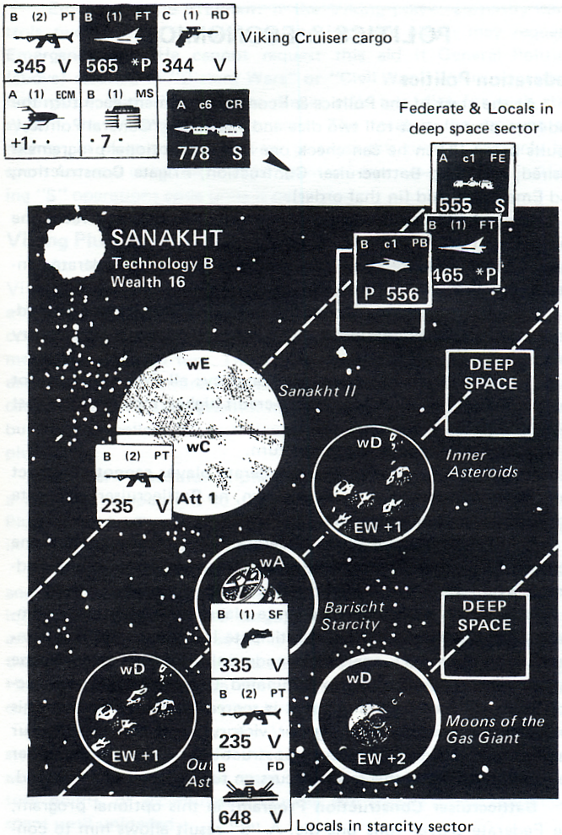
EXAMPLE OF A TACTICAL ACTION: Battle for Sanakht

During the strategic segment of the turn, the Viking player decided to raid Sanakht, and moved his cruiser with cargo there. The Federate player had local forces in the system (of course), as well as just moving a Federate Escort (FE) starship in strategic movement to stiffen the defenses.
The Viking arrival at Sanakht caused a tactical action segment there. First the Federate player deployed his units as shown. The stack of three units (SF, PT, FD) on the capital starcity sector could not be examined by the Vikings, since it was a vacuum sector. The SF unit was on top, concealing the more powerful PT and FD beneath. However, the Federate FE and local PB and FT in the deep space sector of the starcity orbit were all visible to the Viking, as shown.
The Viking player started the first round by moving into the deep space sector in the outer orbit (which also has the Far Moons of the Gas Giant). There was no mutual combat, since no defenders were in that sector. The Federate player decided not to move his spacecraft to the outer orbit deep space, since the FT would have to be loaded and carried on the FE or PB and could not also unload during the same move. So the defender stayed in their original positions, allowing the Vikings to move into the Far Moons sector and plunder it (Viking player rolled a “3” and gained 2 megacredits).
On the third round the Viking player finally moved into the deep space sector of the starcity orbit, unloading his fighter (FT) as he arrived. Note that when entering this new orbit, the Viking was obliged to move into the deep space sector first (hence the logic of the strong Federate deployment there, especially since the valuable starcity had defender penalties). In the mutual combat phase after the Viking move there was heavy firing:
The Viking cruiser (CR) fired its missile pod at the FE (7 attack – 5 defense, +3 EW superiority of CR counting the ECM pod bonus) for a differential of +5, rolled a “7”, and scored a critical hit (CH) that destroyed the FE but also eliminated the missile pod.
The Viking cruiser (CR) fired its normal weapons at the local FT (7 attack –
5 defense +4 EW superiority) for +6, rolled a “9”, and scored a hit that destroyed the FT.
The Viking fighter (FT) fired its weapons at the local PB (6 attack -- 6 defense, +0 EW comparison), rolled a “5” and missed.
The defenders all fired on the Viking CR. The FE had (5 attack – 8 defense
-3 EW inferiority including ECM pod of the cruiser +1 for target unloading) a differential of -5 overall, rolled a “6”, and missed. The PB also had a -5 differential and rolled an “11” for a hit. The FT had (4-8 -4+1) a -7 differential and rolled a “9” and missed. The Viking player elected to lose his pods (only the ECM pod remained) rather than take hit damage to the cruiser itself. Note that if the cruiser itself had taken the damage, the Viking player would have lost one unit (either the RD or PT) still carried as cargo.
The Federate defender, on his movement phase, moved the surviving PB back to the starcity sector, to concentrate his defenses for a last-ditch stand. This left the Vikings alone in deep space, so there was no mutual combat after the Federate move. On the following rounds the Viking player plundered the inner and outer asteroids, as the defenders refused to leave the starcity. Then, finally, the Viking player had to decide whether to attack Sanakht II or the much wealthier starcity. The Viking player considered just moving his fighter (FT) into the starcity sector, to find out the identity of the bottom units in the stack, in order to avoid moving the valuable cruiser into a trap. What would you do now?

POLITICS & ECONOMICS
Federation Politics
At the start of the Politics & Economics segment each turn the Federate player must roll two dice and check the “General Politics-results below. Then he can check one or more optional programs if desired, including Battlecruiser Construction, Frigate Construction, and Emergency Aid (in that order).

General Politics: Federate player rolls two dice and reads the appropriate result:
2, 5 = Depression: all taxes cut in half in all Federate con-trolled star systems for this turn.

3, 4 = Federate Council Avarice: at least half of all Federate (but not local) tax income this turn must be spent on victory points.

6 = Bloated Federate Bureaucracy: all Federate (but not local) construction costs are 1 mega-credit higher, including the cost of victory points.

7 = no special effect this turn.

8 = Fear of Civil War: Federate player cannot construct any “S” operations code units this turn, no Battlecruiser or Frigate Construction programs

9, 12 = Distant Wars: Federate player must eliminate one Frigate (FF) of his choice, including all current cargo. If the Federate player has no frigates, ignore this result.

10, 11 = Civil War: Federate player may voluntarily eliminate blue (Federate) units to participate in the war. Units eliminated without an “S” operations code only count if they can be cargo on an “S” code unit also eliminated. One third (1/3) construction value of each unit eliminated is scored in victory points. This voluntary elimination of units for victory points can only occur immediately, before any new construction or attempting other political programs. If this result occurs on turn 12, roll again instead.

Battlecruiser Construction Program: in this optional program, the Federate player rolls one die. A “6” result allows him to construct the Battlecruiser (BC) unit this turn if desired. A “1” result prohibits construction of all “S” operations code units this turn.

Frigate Construction Program: in this optional program the Federate player rolls one die. A “6” result allows him to construct as many Frigate (FF) units this turn as he desires. A “4” or “5” allows him to construct one Frigate (FF) this turn if desired. A “3” or less prohibits him from constructing any Frigates (FF) this turn. Note that since the Federate player is normally unable to build Frigates, a “3” or less in effect is “no effect”.
Emergency Aid Program: if the Viking player currently controls two or more star systems, the Federate player may request Emergency Aid. He cannot request this aid if General Politics (above) resulted in “Distant Wars” or “Civil War.” When requesting Emergency Aid, the Federate player rolls two dice for each star system the Viking player controls. The total is the amount of money, in mega-credits, he adds to taxes this turn. It can only be spent for new units, but can be spent on any type of units, including “S” operations code units if permitted.

Viking Plunder
At the end of any round in the Tactical Action segment the Viking player can plunder sectors of that star system. To plunder a Viking unit with cargo capacity must be in the sector and no opposing unit also be in that sector. A sector cannot be plundered more than once per turn. The Viking player can also plunder sectors at the end of the entire Tactical Action segment. The Viking player cannot plunder a star system if he controlled it throughout the turn but he can collect taxes instead. The Federate player can never plunder.

Plunder Procedure: to plunder a sector, the Viking player rolls a die and compares it to the wealth code of the sector on the Plunder Table. The result is the value of the plunder to the Viking in mega-credits. Sectors without a code cannot be plundered.

Carrying Plunder: the Viking player notes the plunder received and the unit carrying it. Plunder does not take up cargo space but is loaded and unloaded like cargo, and thus can be transferred to another Viking unit as such. If the unit carrying plunder is destroyed or its entire cargo capacity eliminated, the plunder is lost. Hits that just damage the carrier without eliminating cargo space capacity will not hurt the plunder.

Using Plunder: when the Viking player unloads plunder in a star system he controls (or his home base) he records the plunder as income. It can now be spent for new construction, repairs victory points, or accumulated. Plunder still aboard a unit cannot be spent until unloaded.

Taxation
Each player can tax star systems he controls during the taxation part of the Politics & Economics segment.

Federation Taxes: when the Federate player taxes his systems up to half the wealth value (in mega-credits) goes to the Federate treasury, while the remainder (at least half) must be used as local defense funds for that star system. If the Viking player plundered half or more of his sectors (with wealth codes) in the system that turn, the tax income is only one third (1/3) normal, with fractions rounded down, and all must go to the local defense funds, none is paid to the Federal treasury.
Viking Taxes: the Viking player may tax any systems he controls. Any and all taxes can go to the Viking treasury, although some can be spent for local defense instead if desired. If the Viking player plundered any sector of the system that turn, he cannot collect taxes.

Viking Home Base Taxes: the Viking home base system has a wealth of 10, and always yields this as taxes to the Viking. It can never be plundered by the Viking player.

Use of Funds
Local Defense Funds: this money can only be used to repair existing green (local defense) units in that system, or build new units for the system. Any funds not used are lost. They are never accumulated and cannot be used to “buy” victory points. The player controlling the star system decides how to spend its local defense funds (if any).

Federate Treasury: money paid to the Federate Treasury can be used to repair or build blue (Federate) units in any Federate controlled star system of proper technology, within construction limits. Money in this treasury can also be used to “buy” victory points, at the rate of four (4) mega-credits per victory point. Federate treasury money can be accumulated from turn to turn if not spent, but accumulated “old” funds cannot be used to buy victory points.

Viking Treasury: money paid to the Viking treasury can be used to repair or build red (Viking) units in any Viking controlled star system of proper technology, or the Viking home base. Money in this treasury can also be used to “buy” victory points at the rate of one (1) mega-credit per victory point. Only money just received that turn by the treasury (from unloaded plunder or taxes) can buy victory points. Money can be accumulated but accumulated “old” funds cannot be used for victory points.

Repairs
Treasury Funds can be spent to repair a unit that has suffered. hits, but is not destroyed. Repairs to a C or D technology unit cost one (1) mega-credit per hit removed. Repairs to an A or B technology unit cost two (2) mega-credits per hit removed. Repair of a critical hit (CH) to a Viking Cruiser (CR) or a Federate Battlecruiser (BC) costs ten (10) mega-credits.

Technology Limit: repairs must be performed in a star system with a technology equal or superior to the technology of the unit under repair. There is one exception: if the unit has technology one level superior to the system, repairs are allowed at double the normal cost.

New Construction (Building Units)
Funds can be used to build new units, drawn from the unused and destroyed piles. Cost in mega-credits varies with the type of unit. When building green (local defense) units, if both Viking and Federate players control star systems, purchases alternate: Federate player buys one unit, then Viking player buys one unit, etc. until funds or supply of units is exhausted.

Construction Limit: players cannot build beyond the units pro-vided in the game, once all are in play, no more can be built. A player cannot voluntarily destroy a unit to build it again somewhere else.

Construction Placement: newly purchased units are immediately placed in the star system where the construction funds were spent. Federate and Viking treasury funds can be spent in any con-trolled star system (or the Viking home base, if Viking funds).

Technology Limit: newly built units must be either equal to or one less than the star system technology where they are built. The only exception is the Viking home base, where any technology units can be built. If the Federate player has his blue FD unit (Quadrant Capital) in a B technology system, he can build A technology blue (Federate) units there, but no A technology green units.

New Construction Costs: CR-45, SL-30, BC-60, FF-40, FE-25, PB-6, FT-4, AM-4, GA-7, PT-6, RD-2, SF-2, AG-4, AW-3, TC-2, HO-1, MI-1, missile pod-4, ECM pod-3, repulsor pod-2, FD (tech A)-16, FD (tech B)-10, FD (tech C)-5. Federate player cannot build Battlecruiser (BC) or Frigate (FF) units without proper construction program, see Federation Politics above.

GAME END & VICTORY
Ending the Game
The game is normally 12 turns long. However, the game may end sooner in an “automatic victory” in either of the below situations:

Viking Potential Victory: if the Viking player takes control of the star system that is the Federation Quadrant Capital (had the blue FD unit in it), the Outrim Government collapses, and the Viking player immediately wins, regardless of accumulated victory points.

Points Victory: if either player has a 2-1 or better point advantage for two consecutive turns, starting no earlier than the 7th turn, that player immediately wins after the second such turn. Therefore, the first two turns where this could apply would be the 7th and 8th turns. Exception: if the Federate player has gained any points due to a “civil war” Federation Politics dice roll result, he cannot claim a 2-1 points victory.

Victory Points & Victory
Unless an “automatic victory” occurs, at the end of the 12th turn the player with more victory points is the winner. Remember, victory points can only be “bought” by the Federate player at 4 mega-credits per point, and the Viking at
1 mega-credit per point; accumulated mega-credits cannot be used, only freshly received ones. Therefore, both players are normally buying points through-out the course of the game.

Normally victory point purchases are announced at the end of each turn. However, as an optional rule players may wish to keep purchases secret until the end of the game for greater suspense.

Game Variations
A number of variations to Star Viking are possible. One is a solitaire game using dice rolls to control Viking interstellar movement, which can add some interest and excitement. Any enterprising player could construct tables for this.

Another possibility is an enlarged game combining two game sets, and having two Viking and one Federate player. The Viking players” are separate, and mutually hostile. The Federate player has double the forces and star systems (18-20) of the normal game, and can form them into one large or two small quadrants (blue FD for each Quadrant Capital, if two are used). If two invaders are in the same system at the same time, the invader with the higher victory points moves first in that segment. The two Viking players are mutually hostile, and may fight against each other.

The easiest variant is simply to extend the game to 20, 30 or more turns. In this case, victory points should be revealed every 5 or 10 turns, and no automatic victories allowed. However, each turn the Vikings control the Quadrant Capital they gain 30 extra victory points, but the Federate player gets 20 extra mega-credits in free Emergency Aid.

ERRATA

Errata to 1st Edition – 10/20/81
Carrying Cargo: local green units cannot be carried outside their original star system as cargo. If they are, the local unit is instantly destroyed. This is because locals have various racial types requiring various habitats, technologies, incompatible with each other and the Federation, and because their military equipment when carried elsewhere will lack the necessary maintenance, supply, support, and command services for proper functioning. Locals that leave their system become ineffective and, therefore, are removed.

Copyright © 1981, Heritage USA

